36.3: The angle to the first dark fringe is simply:
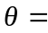 arctan 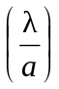 = arctan 